**Year 1**



**BSc (Hons) in Information Technology**



**Tutorial 6**

**IT1010**  **– Introduction to Programming** **Semester 1, 2020**

# Question 1

Draw a flowchart to input an integer from the keyboard and display whether the number is positive, negative or zero. If the number is > 0 display “number is positive”. If number is zero display “ Number is zero”. Otherwise display “Number is negative”.

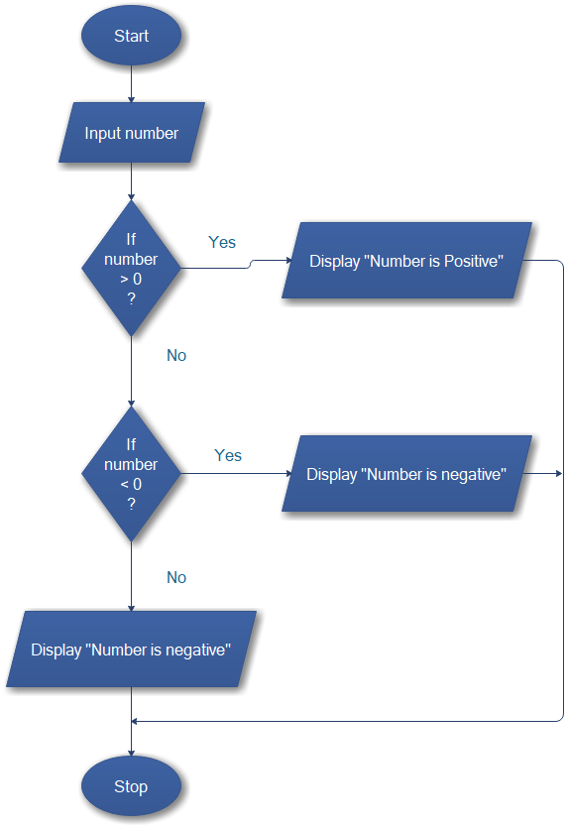

Convert the flowchart to a C program.

#include <stdio.h>

int main (void){

    int number;

    printf("Input Number : ");

    scanf("%d",&number);

    if(number > 0){

        puts("number is positive");

    }else if(number < 0){

        puts("number is negative");

    }else{

        puts("number is zero");

    }

    return 0;

}

# Question 2

Draw a flow chart to enter a number from the keyboard and print whether it is an even number or an odd number.

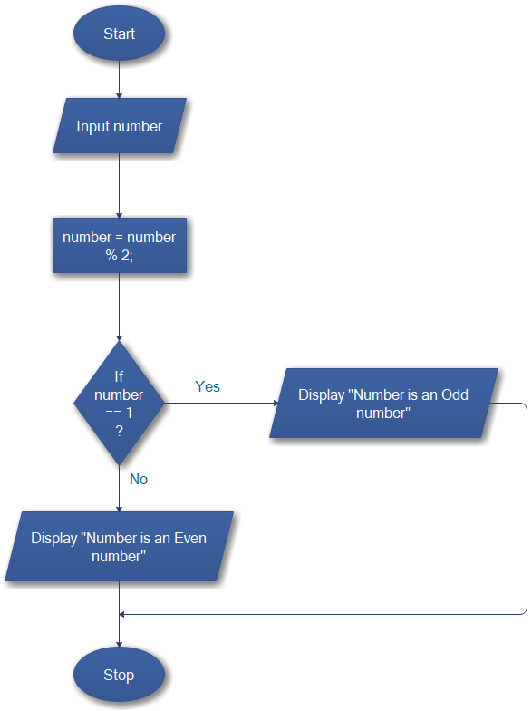

Convert the flowchart to a C program.

#include <stdio.h>

int main(void) {

    int number;

    printf("Input Number : ");

    scanf("%d", &number);

    number = number % 2;

    if (number == 1) {

        puts("Number is an Odd number");

    } else {

        puts("Number is an an Even number");

    }

    return 0;

}

# Question 3

A palindrome is a number or a text phrase that reads the same backward as forward. For example 12321, 45554. Write a C program that reads a five-digit integer and determines whether it is a palindrome or not.

# Question 4

Write a C program to input the grade from the keyboard and print the respective messages. (Use if-else statements and upper and lower case both should be allowed when entering the grade)

|  |  |
| --- | --- |
| **Grade** | **Message** |
| A | Excellent |
| B | Good |
| C | Satisfactory |
| F | Needs Improvement |

#include <stdio.h>

int main()

{

    char grade;

    printf("Input the Grade : ");

    scanf("%c",&grade);

    if(grade == 'A' || grade == 'a'){

        puts("Excellent");

    }else if(grade == 'B' || grade ==  'b'){

        puts("Good");

    }else if(grade == 'C' || grade ==  'c'){

        puts("Satisfactory");

    }else if(grade == 'F' || grade == 'f'){

        puts("Needs Improvement");

    }else{

        puts("Invalid Grade");

    }

    return 0;

}

# Question 5

Re-write the answer for question 4 using switch statements.

#include <stdio.h>

int main(void)

{

    char grade;

    printf("Input the Grade : ");

    scanf("%c",&grade);

    switch(grade){

        case 'A':

        puts("Excellent");

        break;

        case 'B':

        puts("Excellent");

        break;

        case 'C':

        puts("Excellent");

        break;

        case 'F':

        puts("Excellent");

        break;

         case 'a':

        puts("Excellent");

        break;

        case 'b':

        puts("Good");

        break;

        case 'c':

        puts("Satisfactory");

        break;

        case 'f':

        puts("Needs Improvement");

        break;

        default:

        printf("Invalid Grade");

    }

    return 0;

}

# Question 6

Convert the following switch statement to an equivalent if-else statement.

switch ( grade ) {

case 'A' :

printf( "Excellent \n");

break; case 'B' :

printf( "Good \n”); break; case 'c' : case 'C' : printf( "OK \n"); break; default :

printf( "Needs Improvement\n”);

}

#include <stdio.h>

int main(void)

{

    char grade;

    printf("Input the Grade : ");

    scanf("%c",&grade);

    if(grade == 'A'){

        printf( "Excellent \n");

    }else if(grade == 'B'){

       printf("Good \n");

    }else if(grade == 'C'){

       printf( "OK \n");

    }else{

        printf( "Needs Improvement\n");

    }

    return 0;

}

# Question 7

A company calculates the bonus given to their employees based on the employee category. Write a C program to input the employee category and basic salary and calculate the bonus amount.

Employee category Bonus percentage

1. 5%
2. 10%
3. 15%

Bonus = Basic_Salary * Bonus_Rate

#include <stdio.h>

int main(void)

{

    int employeeCategory;

    float eBSalary;

    float bonusAmount;

    printf("Input the Employee category : ");

    scanf("%d",&employeeCategory);

    printf("Input the Employee basic salary : ");

    scanf("%f",&eBSalary);

    if(employeeCategory == 1){

       bonusAmount = eBSalary *5/100;

       printf( "Bonus amount is %0.2f",bonusAmount);

    }else if(employeeCategory == 2){

      bonusAmount = eBSalary *10/100*100;

      printf( "Bonus amount is %0.2f",bonusAmount);

    }else if(employeeCategory == 3){

      bonusAmount = eBSalary *15/100*100;

      printf( "Bonus amount is %0.2f",bonusAmount);

    }else{

        printf( "There is no any category like that");

    }

    return 0;

}